**Fanka Shundovska**

**POSTMAN Homework**

In Postman:

- create a new collection called **Homework Postman 1**

- then add the APIs from the dummy site http://dummy.restapiexample.com/ (Click on Details on each request to check if that request has a Sample Json that we need to pass in the request body)

- also on some requests it can happen that we get a response status code 429 Too Many Requests

**Note:**

Upload the homework as a zip file, including the exported postman collection.

(Check ExportingPostmanColectionInstructions.pdf **file** for instructions)

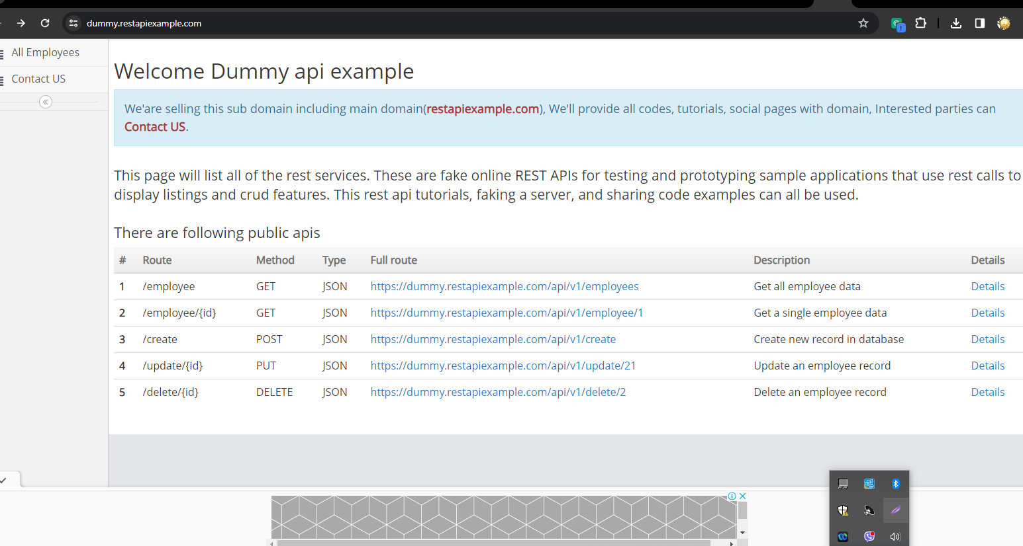

**Get All Employees**

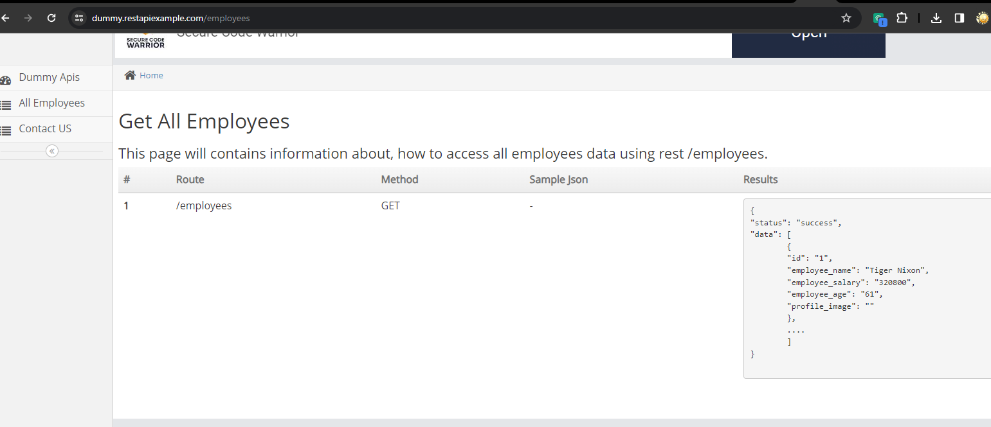

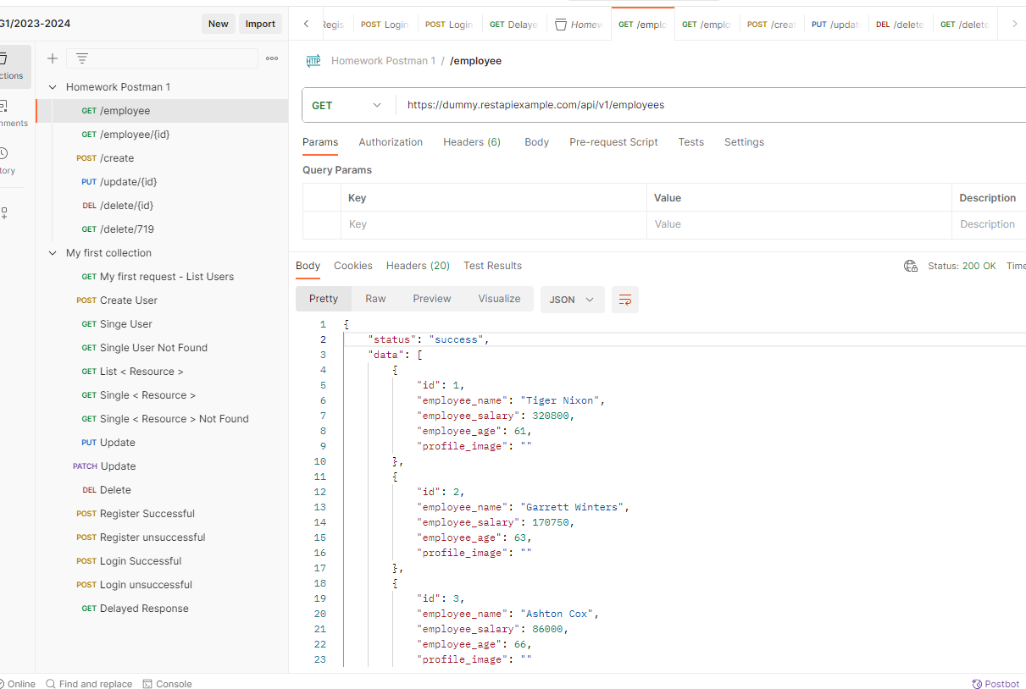

**Get A Single Record**

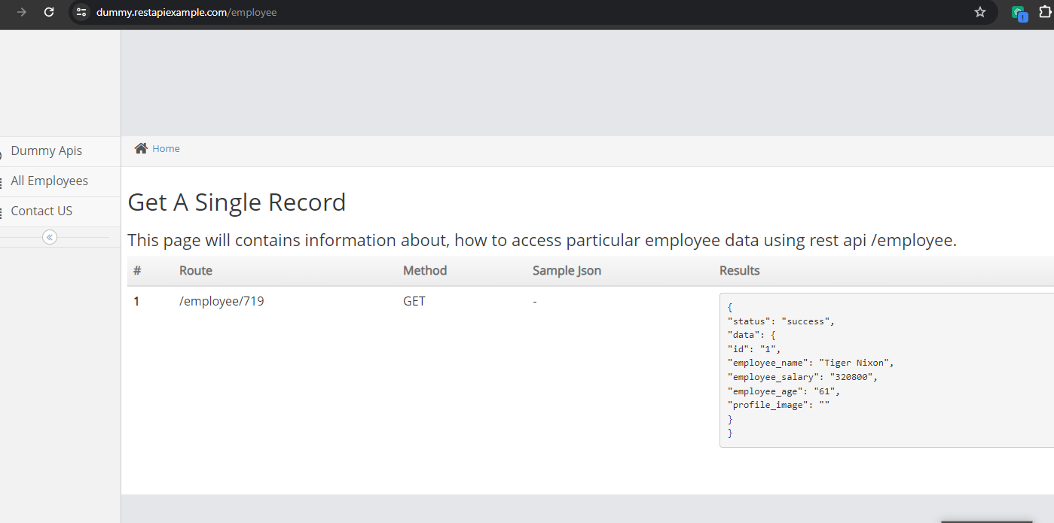

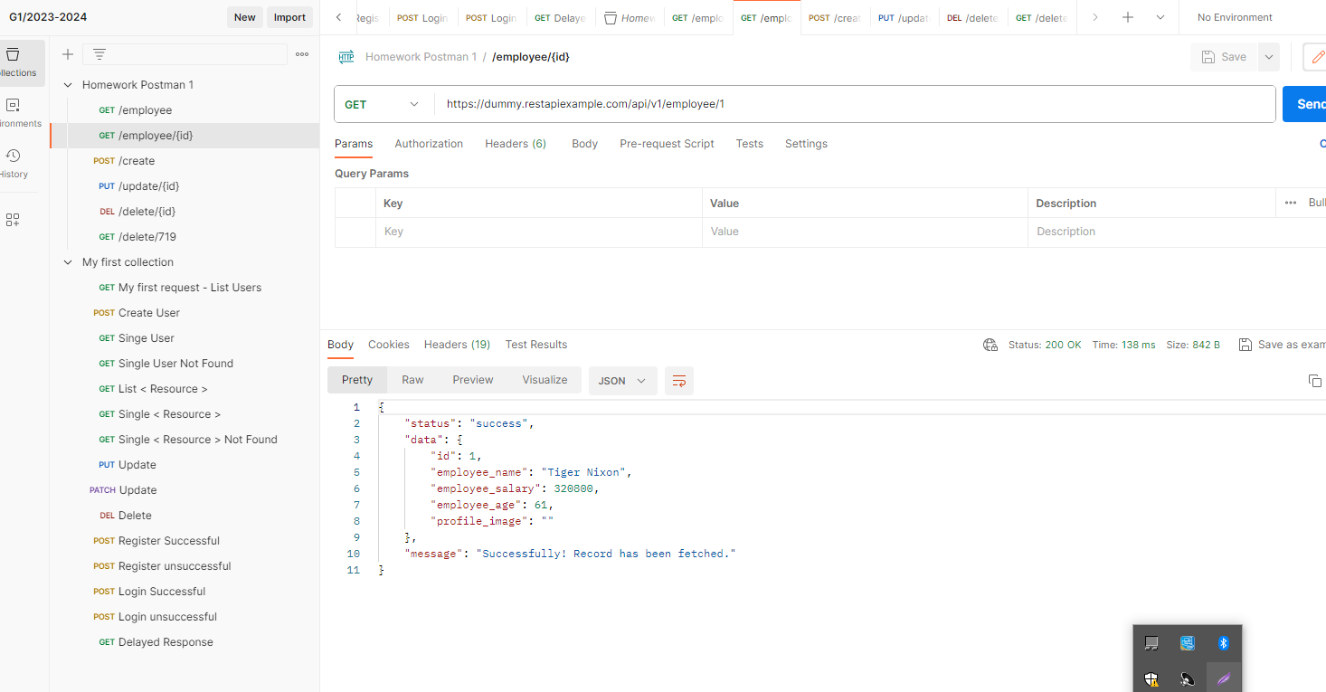

**Create A Record**

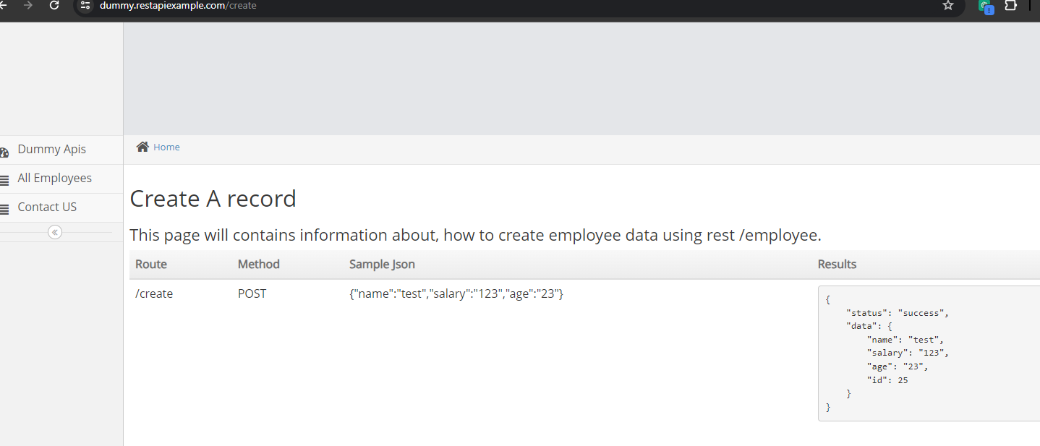

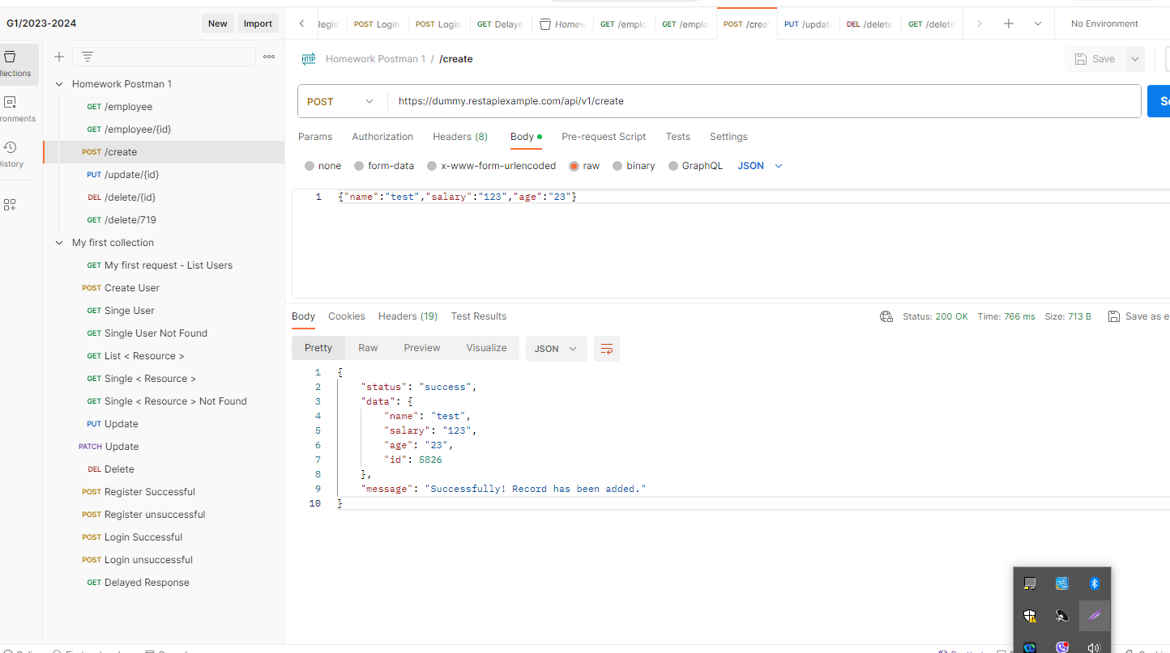

**Update A Record**

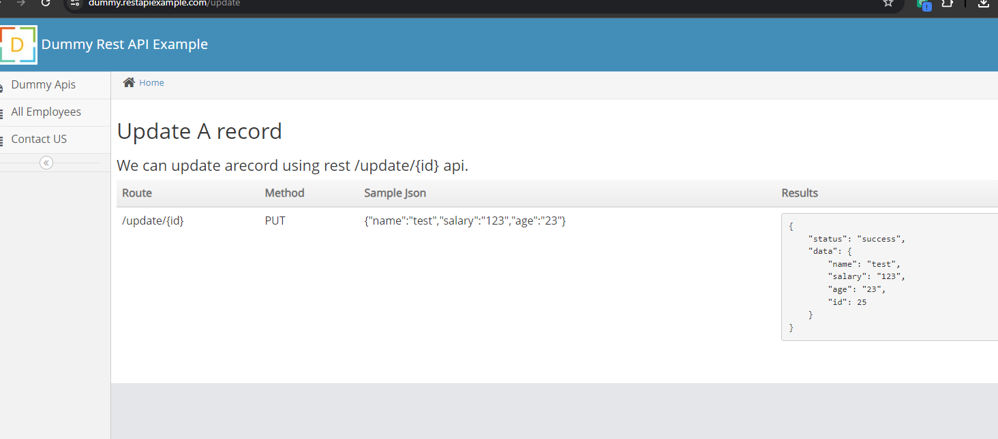

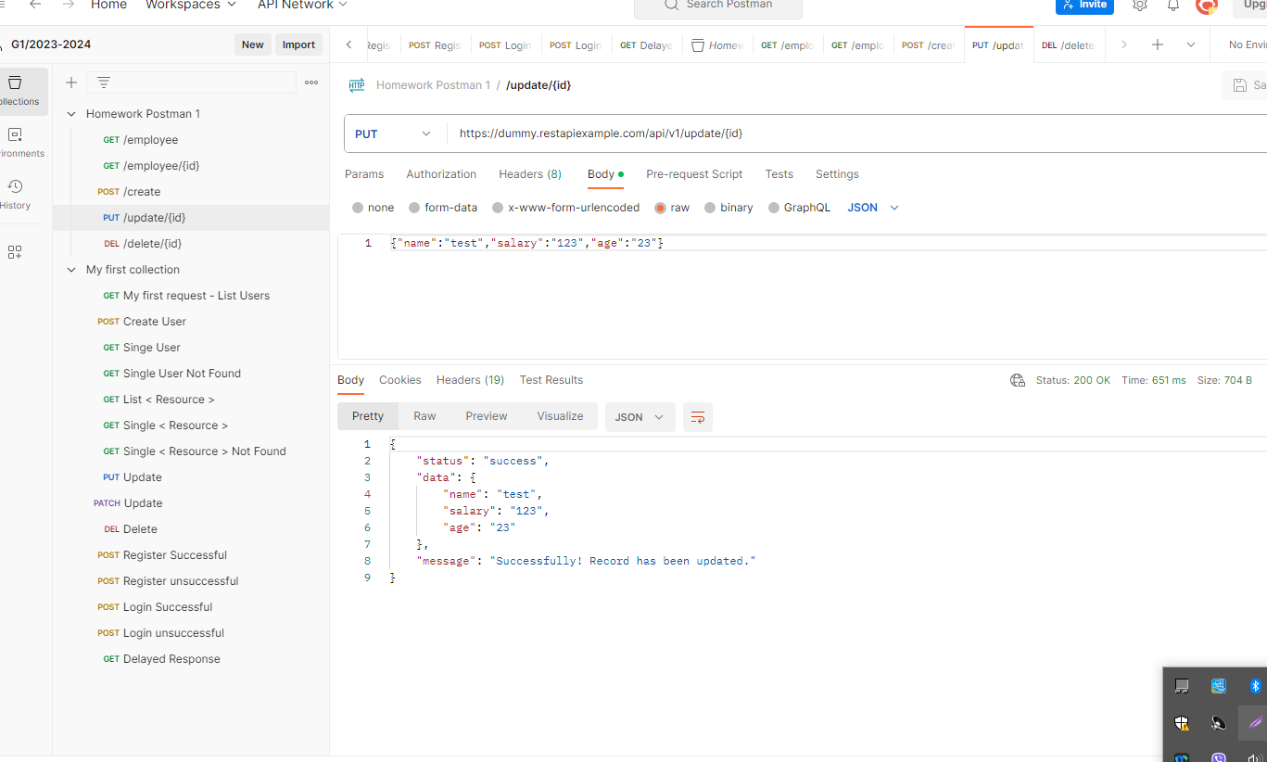

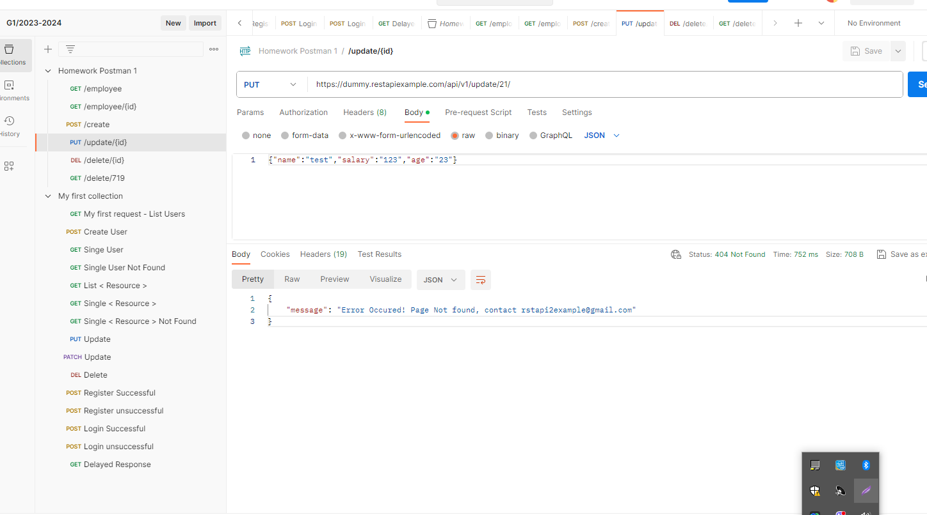

**Delete A Record**

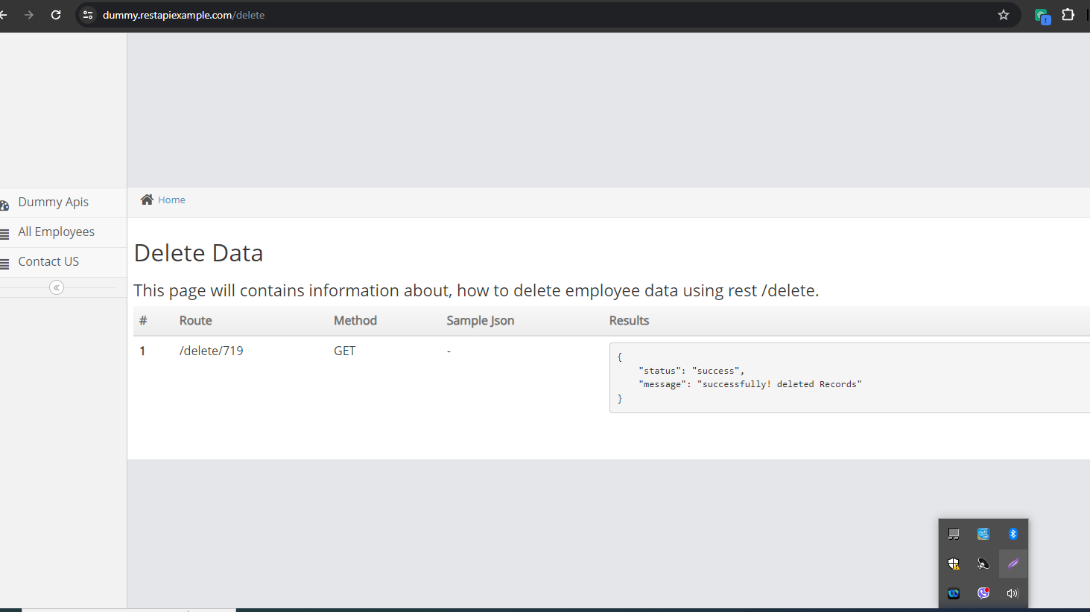

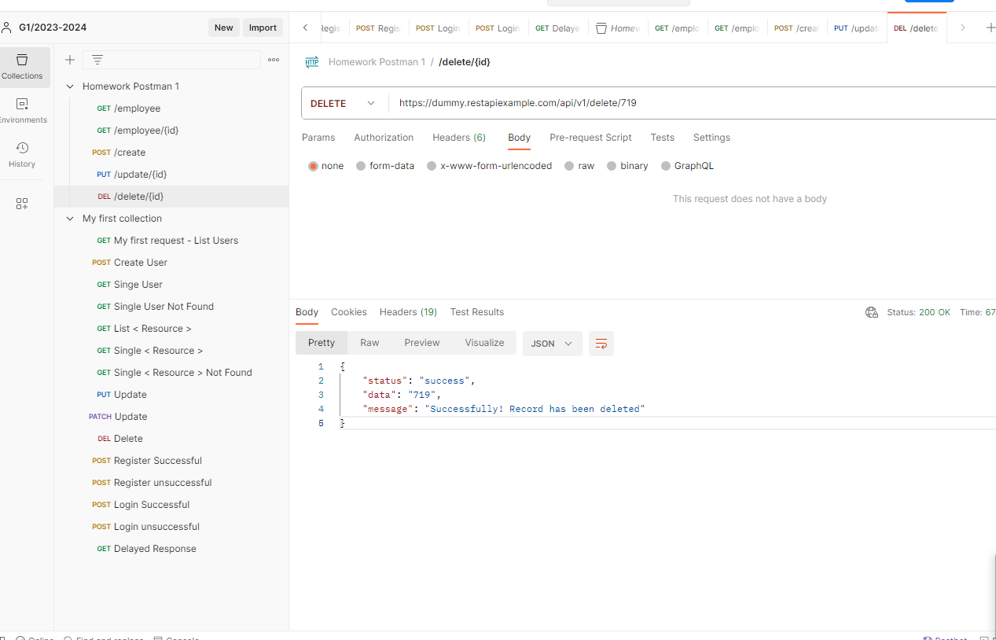

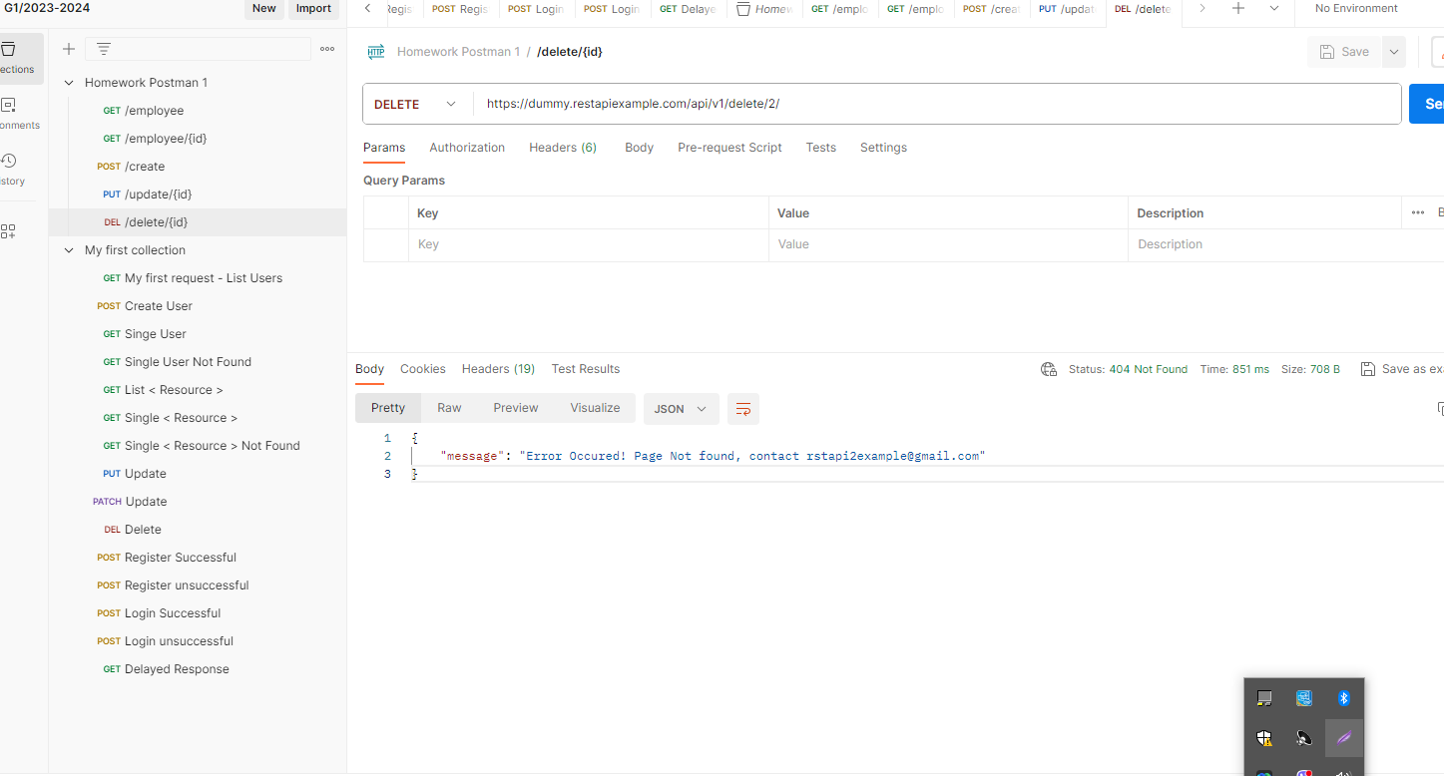

**NOTE!!!**

**There are BUGs in the Put and Delete APIs with the First URL, we don’r receive a request as it written in the APIs. We receive the requested results with the Route given in the information needed to create different data.**